# Developing Content Management and Certificates plugs

In the explorer, once you stand on a folder (in the TreeView) you will get the folder’s data properties on the right:

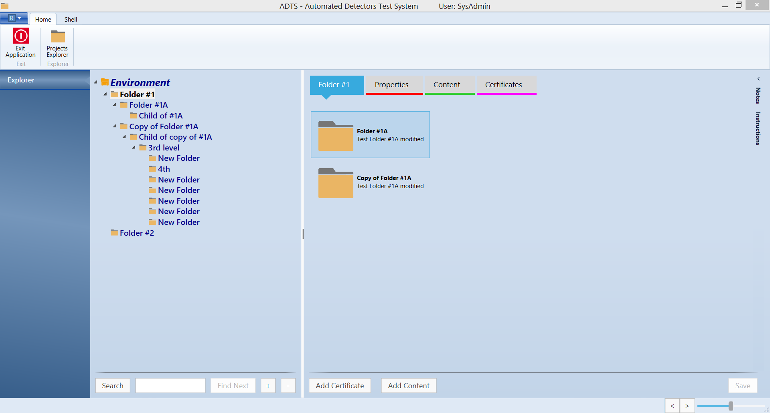

When you press the ‘Add Content’ button, the right Flyout will be opened:

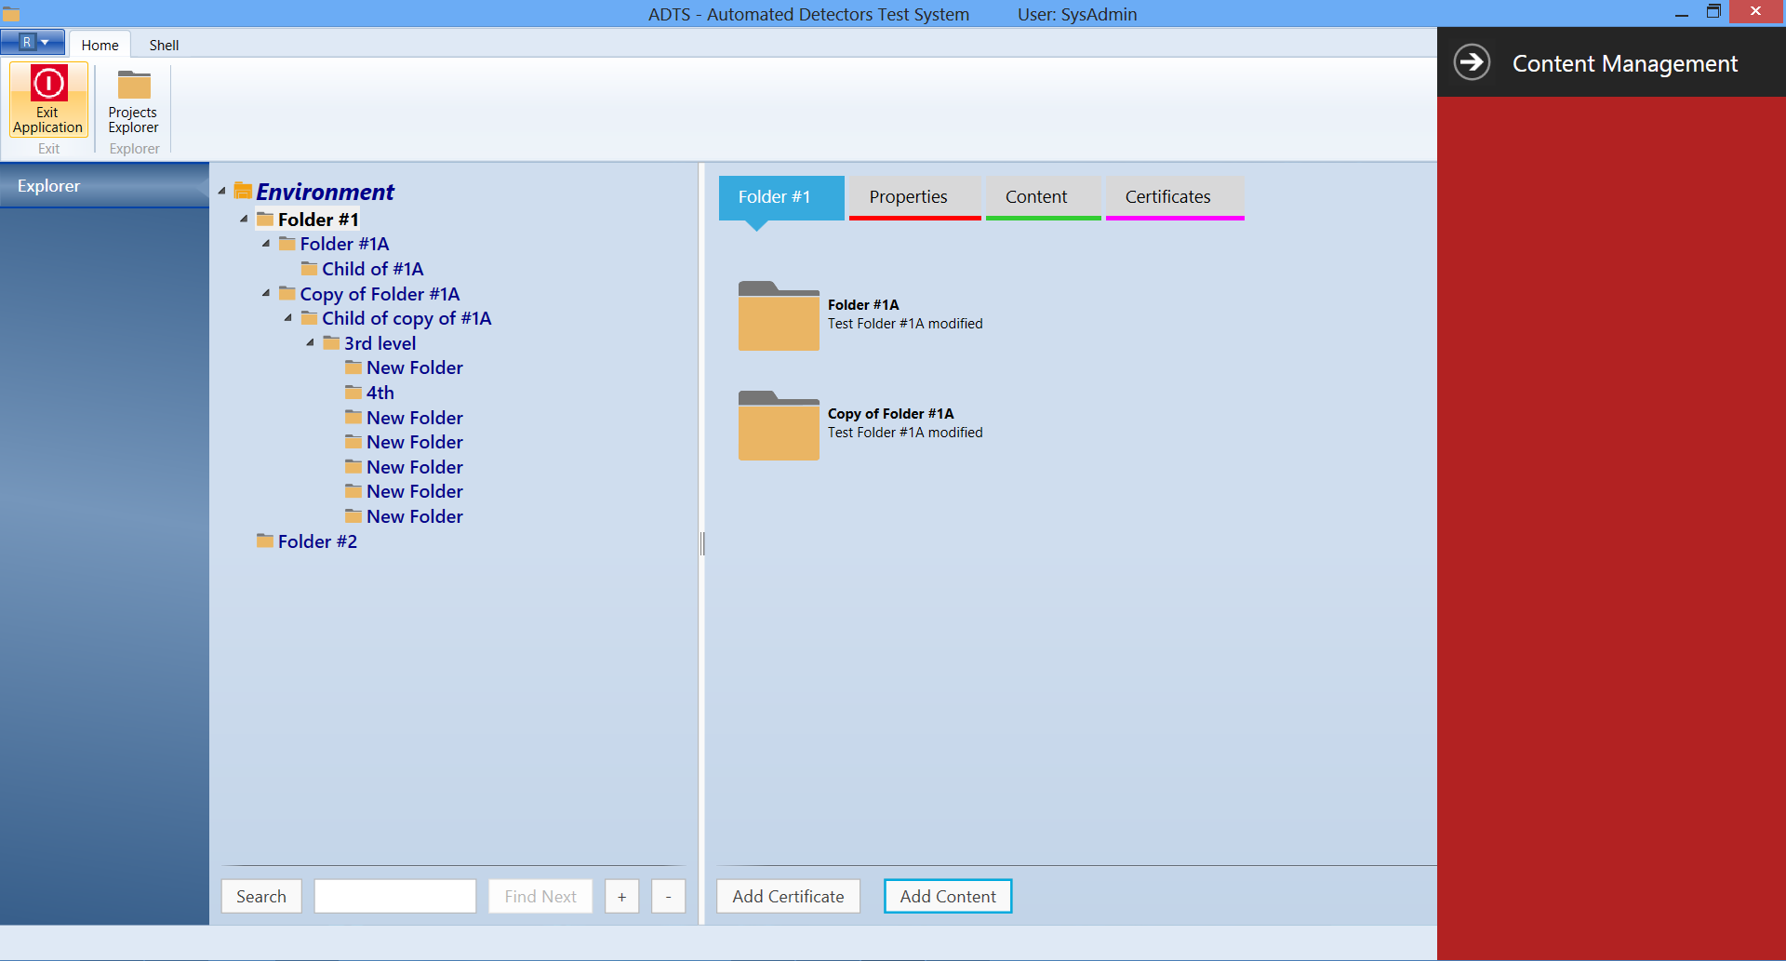

In a similar manner, we have a call to the Certificates when you press the ‘Add Certificate’ button:

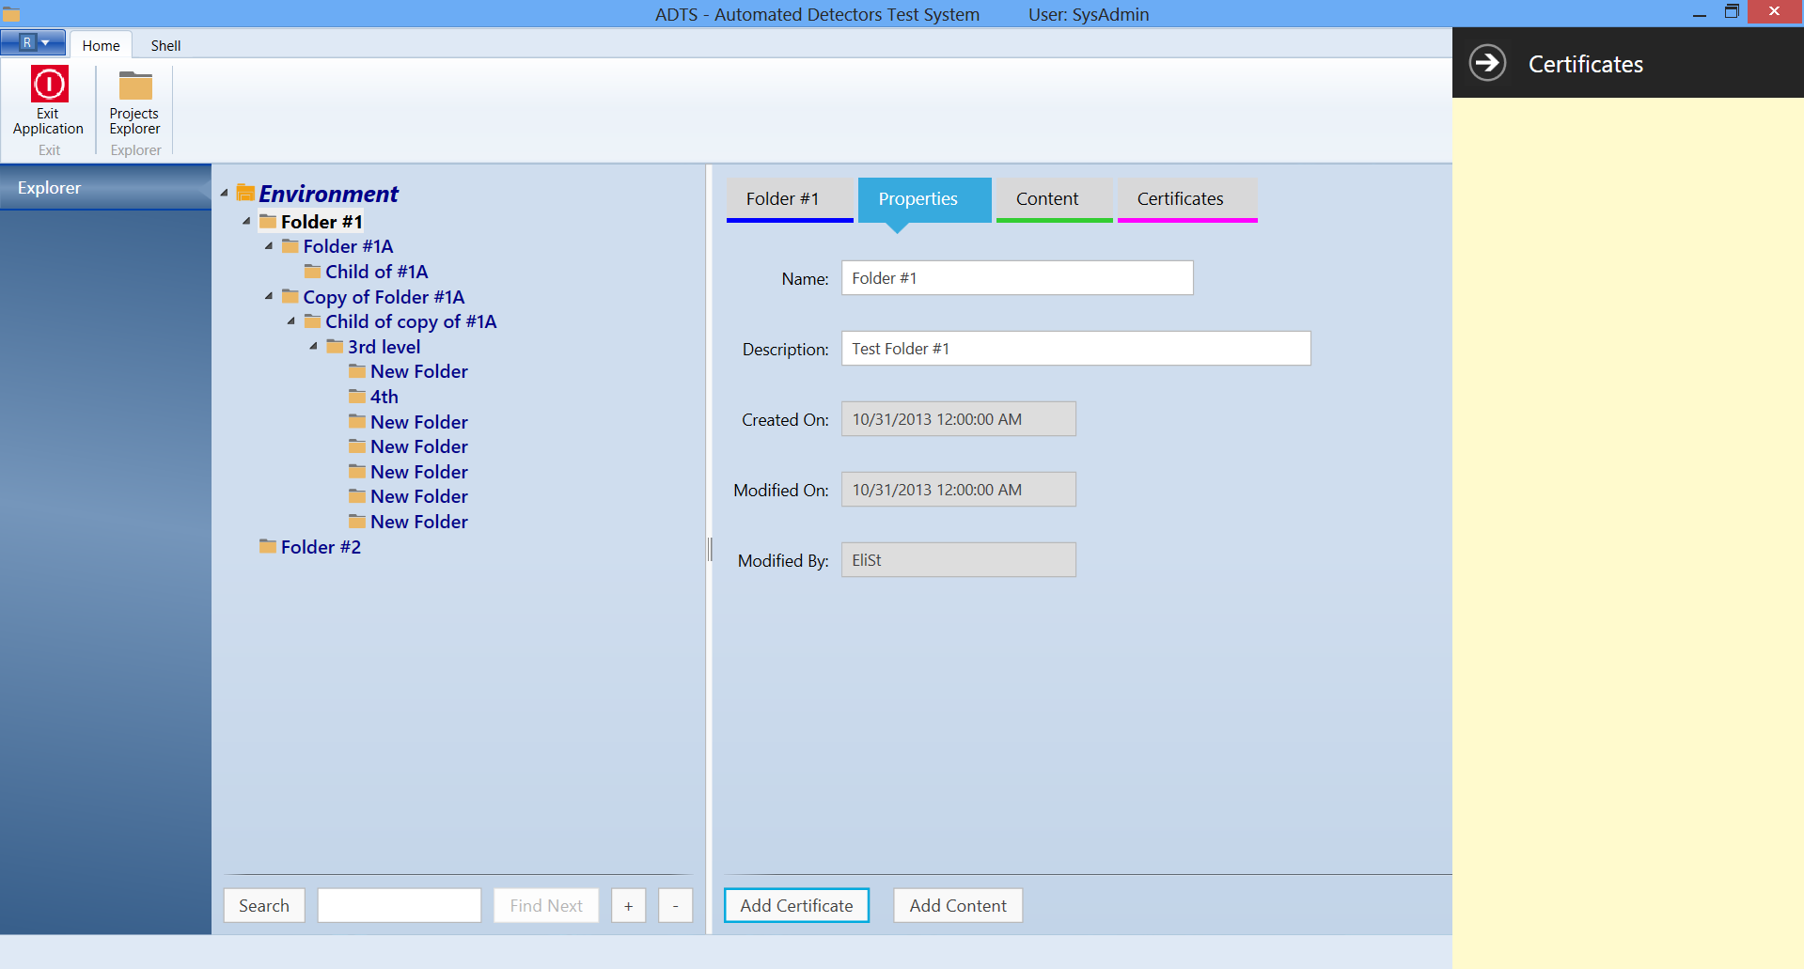

## Development Instructions – Content Management

* In the Flyout we should have a TreeView that will present the data we receive via the interface with SCD’s Content Management. Once this TreeView is shown, the user will be able to perform Drag from a TreeView node onto the content tab of the Folder\Project.
* I have already created the entire mechanism, as shown above. All the messages that flow from the Folder’s ViewModel (VM) to the MainWindow VM (that tell it to open the Flyout and which control to present there) are done.
* You need to develop the mock to Content Management that will return to you a Dictionary (or any other collection data type, as agreed with Alex). Once you get this, you will populate a TreeView.
* Make sure you see how I did the TreeView of the Explorer. You need to do the same. A TreeView in MVVM is a hierarchical collection of VMs, each entry in the collection is a VM and a View.
* You need to do all your work inside the User Control I prepared (ContentManagementView and ContentManagementViewModel), both located in the ExplorerModule project.
* The Mock itself should be developed outside of our solution, and the compiled dll should be added as a reference to the ExplorerModule project. When we receive from Alex his final dll, we will drop the reference to the mock and include a reference to Alex’s dll.
* Make sure the data you generate in the mock has enough content and hierarchy levels to simulate the live data we will get.
* Once everything is created, we will add the Drag and Drop capabilities between the Content TreeView and the target ListView in the Folder (which is not created yet).

## Development Instructions – Certificates

* Similar to the above, only the interface with SCD is not defined yet and should be clear. I don’t know if the data returned from there is hierarchical (and therefore should be presented in a TreeView) or flat (and therefore should be presented in a ListView).
* The View is called CertificatesView, and there is a respective VM.